Year 2 English Revision Pack

Dear Parents,

We will be starting the GL assessments. Here is the English revision pack to help you revise some of the topics we have covered in English this year with your child at home.

Schedule of Assessments:

Week 1 week beginning - week beginning 27th Sept ( Wednesday and Thursday) | English
Week 2 - Week beginning 4th Oct | Maths (Arithmetic and Reasoning)

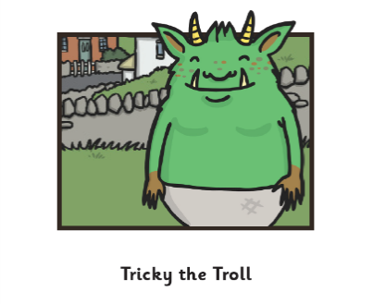
Message to parents:
Parents can read the text to your
child. Do not read the questions.
Children must read questions independently.

Tricky was a troll. A huge, green
Where did Tricky the troll live?
Choose 1.

Blue Village

Green Hill

Under the bridge

Beside the river

and brown smelly troll. He lived
under the bridge in Green Village
with his three brothers, Stinky,
Snotty and Slimy. The three older
brothers spent their days scaring
children. Each time a child would
try to cross the bridge, the trolls
would jump out and roar at them
loudly! The child would run off,
screaming. Nearly all of the villagers
were scared of the trolls.

Tricky wasn’t like his brothers. He
Why did Tricky’s brothers tease him?
Choose 1.

He was scared of children.

He was scared of his brothers.

He was always sad.

He wanted to be friends with
the children.
was kind and friendly. He didn’t want to jump out and scare the children, he wanted to play with them. But each time he tried to talk to a child, they would run off! He was so sad.
His brothers just laughed and teased him. They called him ‘Terrified Tricky’ and told him he was silly for wanting to make friends with the children.
“Children are for caring not for playing with!” his biggest brother Slimy told him.
“You need to start roaring at them like us!
It’s funny when they start to cry!”

Tricky walked away from them sadly.
Why did Tricky walk away from them sadly?
Choose 1.
Because his brothers scared him.

Because his brothers were so
different to him.

Because he fell over and hurt
himself.

Because the little girl scared
him.

“That’s unkind!” replied Tricky, “I don’t want to be unkind. I want to be friendly and helpful.”

“Helpful? Friendly?” scoffed Snotty, wiping his nose up his arm. “We are trolls, we scare people, we make children cry.
We are not friendly!”

Tricky walked away from them sadly. He would never be like them. He went to sit in his
favourite tree to watch the children play in the park.

What time of the day was it when the trolls heard the little footsteps of the little girl on the bridge? Choose 1.

It was the afternoon.

It was sunrise.

It was sunset.

It was night time.

Meanwhile, the older three brothers sat under their bridge waiting for the next
child to scare. Just as the sun was starting to go down, they heard little footsteps on the bridge. Stinky grinned at his brothers, and without a sound, jumped up onto the bridge
and roared his scariest, loudest roar. The girl jumped in surprise, but she didn’t cry.
She just stood looking at Stinky. Then, after a moment, she smiled! Stinky stared at the little girl. Why wasn’t she crying?
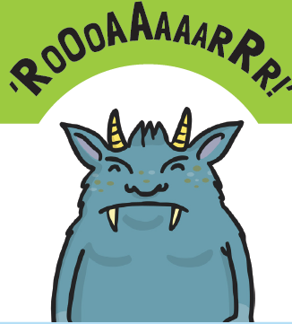

Underneath the bridge, Snotty looked at his brother. “Why isn’t she crying?” he whispered to Slimy. “I don’t know,” growled Slimy angrily. “Go and help Stinky!”
How do you know the little girl was not scared of the trolls? Choose 1.

She roared at them.

She started to cry.

She started shaking
her head at them.

She smiled at them.
Snotty took a deep breath, jumped up onto the bridge and roared his scariest roar, showing the little girl his
yellow and black teeth. The little girl looked at Snotty and then smiled at him too!
Snotty stopped roaring, in in surprise.
Underneath the bridge, Slimy sighed, shaking his
head. “I’ll frighten her!” he said to himself.

Why did the trolls try to run away from the little girl? Choose 1.

They didn’t want her to hug them.

They thought she
would hurt them.

They were scared of the
little girl.

They thought the little girl
wanted to eat them.

He took a deep breath, jumped out and roared and growled at the little girl, showing his sharp teeth and claws. But the girl just laughed. “You’re funny!” she giggled. “I’m going to take you home and hug you all night!” She ran up to the trolls to give them a huge hug!

The trolls screamed and tried to runaway from the little girl. But they couldn’t, she just kept chasing them! “Stand still so I can hug you, you troll,” she giggled.
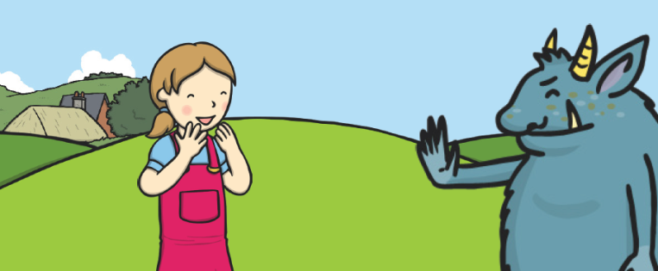

In his tree, Tricky had heard the
He couldn’t believe his eyes.
What does this tell you about how Tricky felt?
Choose 1.

He felt angry.

He felt upset.

He felt shocked.

He felt happy.
screams from the bridge. He turned to look and saw his brothers being chased around the bridge by a tiny little girl! He
couldn’t believe his eyes. He jumped down from the tree and ran back to the bridge. When he got there, he found his brothers huddled together against the rail of the bridge. “Please leave us
alone! We don’t like hugs,” they cried. As the little girl covered them with hugs.

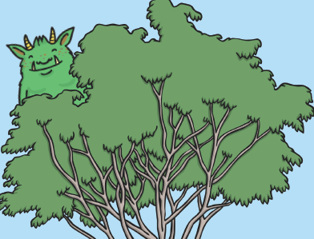

He laughed loudly. The little girl turned around. “Who are you?” she asked.
“They aren’t cute, they’re dreadful’” said Tricky.
What does the word dreadful mean?
Choose 1.

sad

kind

horrible

funny
“I’m Tricky,” he replied. “What are you doing to my brothers?”
They are so funny and cute,” replied the little girl. “I want to take them home and play with them!” They aren’t cute, they’re dreadful,” said Tricky.
“They like to scare people all day. But I would like to have a friend to play with.”
“Really?” asked the girl. “Well come on, let’s go to the park and play!” And off they skipped happily together.

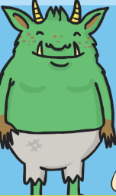
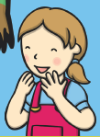

Match the words that rhyme. One has been done for you.
Practice question
might

chair
made
kite
flag

soap
Q1.

late
brown
hope
slip

paw
Q2.

door
tape
drip
slope

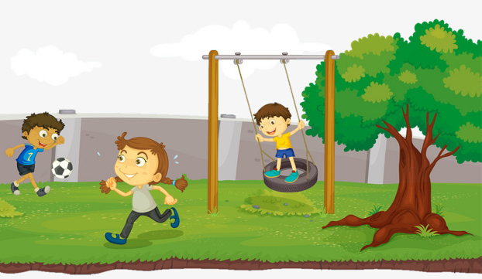

Choose the sentences that match the picture.
Choose 2 boxes.

The girl is in swinging on the swing.

The tree is short and red.

The girl is sweating.

The boy is kicking the football.

The boy is wearing a red t-shirt.

Circle the correct spelling in the gap

meat
meet
- The word carnivorous means to need _________ (from animals) for survival.
even

- So that means carnivorous plants are plants that eat bugs and
even
eve

____________ animals like frogs.
it
eat

- What! Are there really plants that ______?
word
world

- Yes, there are. In fact, there are 630 different kinds of carnivorous
word
world

plants around the __________.

sum
- Some carnivorous plants are water plants (they live in the water) and

some
sum

_______ live in the soil like most other plants do.

Which words should start with a capital letter?
Choose / Circle 3.

today I will got to the united kingdom.

This sentence has two commas (,) missing.
Tick 2 boxes to show where the commas should be.

I went to the shop to buy eggs milk cheese and sweets.

Choose the correct word from the boxes to complete each sentence. One has been done for you.
am
is
are
will

- I ______ seven years old.

am
is
are
will

- It ______ raining today.
Choose the correct word to complete each question.
One has been done for you.

_ __ is your name?

_________ do we need to sleep?

__________ do you prefer, swimming or skipping?

_________ many marbles do you have?

_________ is playtime?

________ is your school bag?

How

Website Links

Visit Year 1 and Year 2 YouTube channels to access videos to recap and revise

Year 2
https://www.youtube.com/channel/UC3vV9h2z-e9wWzrh2-VuD9Q

Year 1
https://www.youtube.com/channel/UC0EHHYnUEiVw23qxcD-5kEQ

