Year 2 Maths Revision Pack

Dear Parents,

We will be starting the GL assessments. Here is a Maths revision pack to help you revise some of the topics we have covered in Maths with your child at home.

Schedule of Assessments:

Week 1 week beginning - week beginning 27th Sept ( Wednesday and Thursday) | English
Week 2 - Week beginning 4th Oct | Maths (Arithmetic and Reasoning)

- Name these shapes and describe their properties
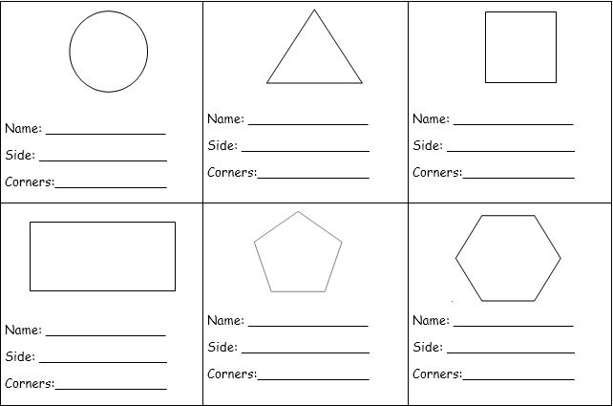

- Use a ruler to draw one line of symmetry through the following shapes.

3. This pictogram shows Class 1’s favourite sport
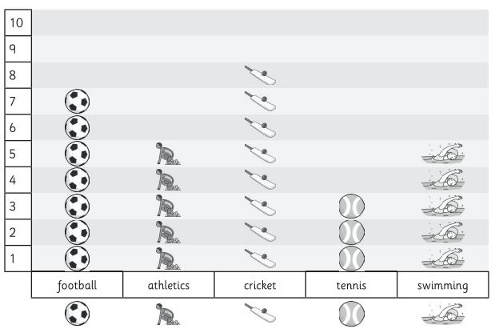

- How many children chose cricket?

- Which sports are equally popular?

- Which is the least popular sport?

- How many more children chose football than tennis?

- How many children are in Class 1?

4. Here are some coins:
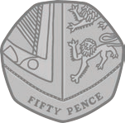

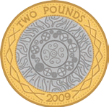

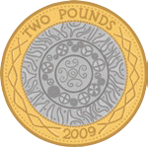

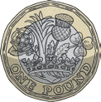

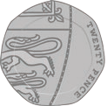

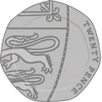

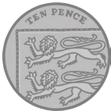

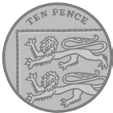

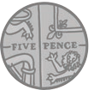

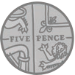

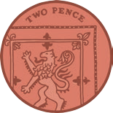

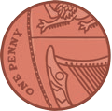

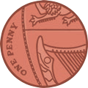

Draw coins to show one way of making the following amounts of money.
Example: 17p
10p
5p

2p

- 34p-

- £1.22

- 65p-

5. An apple costs 42p. How much change would you get from 50p?

p
42p

6. How much more is the ball than the boat?
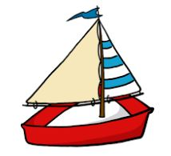

65p
34p

7. Here is a calendar showing the month of January
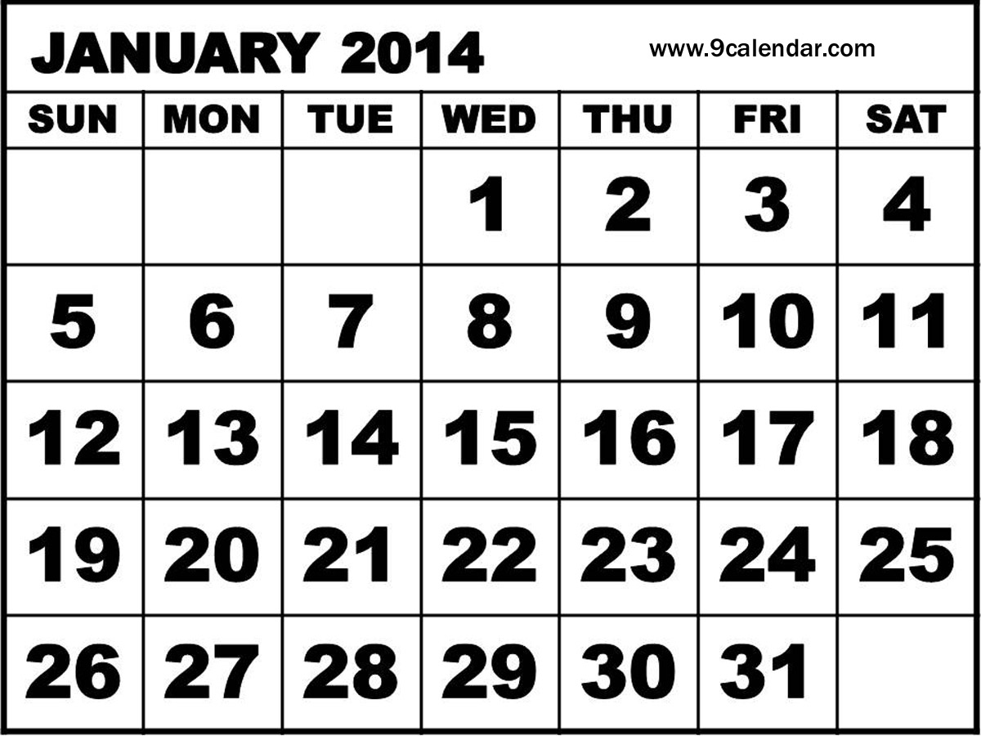

- Fill in the missing dates

- How many Thursdays in January?

- What day is the 24st of January?

- How many days in January?

8) A shop sells 8 t-shirts in 1 day.
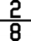
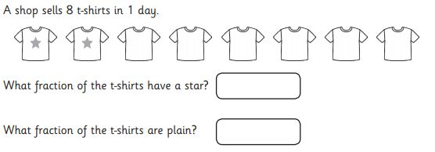

9. A man has 6 pets. What fraction of the pets are dogs?

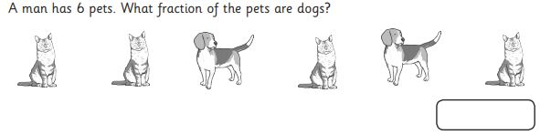

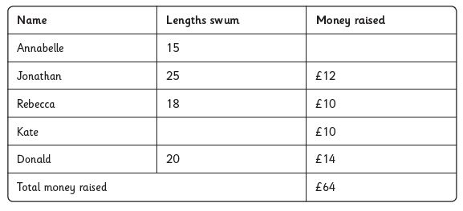
10. Some children did a sponsored swim to raise money for new books for their school.

- Who swam the most lengths?

- Which two children raised the same amount of money?

- Kate swam 8 lengths more than Annabelle. How many
lengths did she swim?

- How many more lengths did Jonathon swim than Rebecca?

- Annabelle raised £6 more than Jonathon. How much money did she raise?

11. The Hundred Square
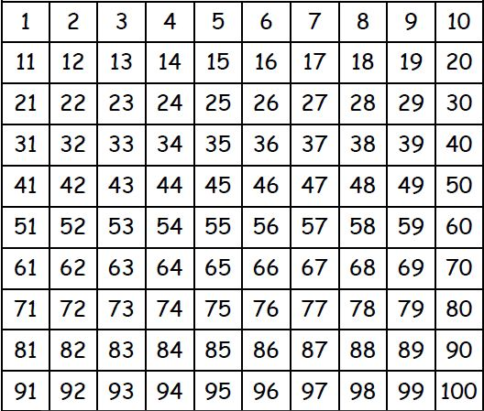

Colour all the odd numbers red and the odd numbers blue.
Write down an odd number more than 75

Write down an even number less than 30.

What number is 8 more than 61?

What number is 7 less than 35?
12. What time is it?
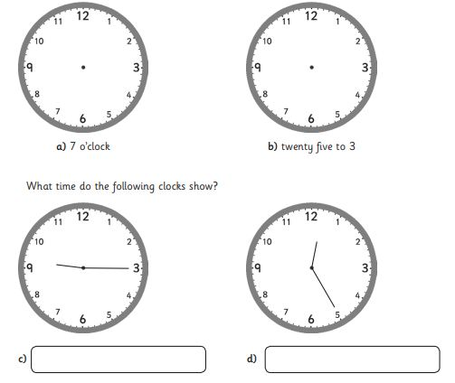

13. Write a multiplication or division sentence around the following pictures
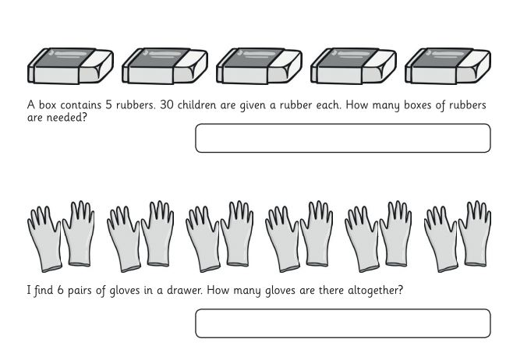

Website Links

Visit Year 1 and Year 2 YouTube channels to access videos to recap and revise

Year 2
https://www.youtube.com/channel/UC3vV9h2z-e9wWzrh2-VuD9Q

Year 1
https://www.youtube.com/channel/UC0EHHYnUEiVw23qxcD-5kEQ

Maths Websites

Shape
https://www.topmarks.co.uk/maths-games/5-7-years/shapes

Ordering Numbers
https://www.topmarks.co.uk/ordering-and-sequencing/caterpillar-ordering

Place Value
http://www.ictgames.com/sharkNumbers/mobile/index.html

All Maths Topics
http://www.ictgames.com/resources.html
https://uk.ixl.com/math/year-2

