 

**Year 2 Maths Revision Pack**

Dear Parents,

We will be starting the GL assessments. Here is a Maths revision pack to help you revise some of the topics we have covered in Maths with your child at home.

**Schedule of Assessments:**

|  |  |
| --- | --- |
| Week 1 week beginning - week beginning 27th Sept ( Wednesday and Thursday) | English |
| Week 2 - Week beginning 4th Oct | Maths (Arithmetic and Reasoning) |

1. **Name these shapes and describe their properties**

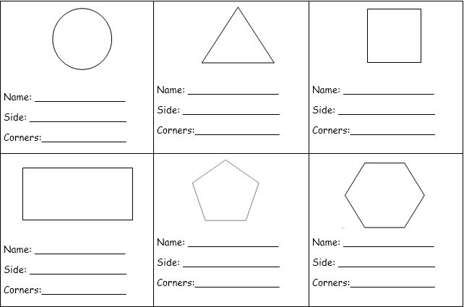

6

6

Hexagon

5

5

Pentagon

4

4

Rectangle

4

4

Square

3

3

Triangle

0

1

Circle

1. **Use a ruler to draw one line of symmetry through the following shapes.**

**3. This pictogram shows Class 1’s favourite sport**

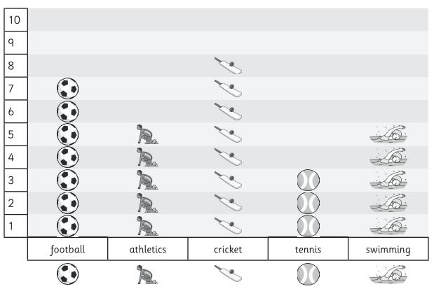

8

1. How many children chose cricket?

Athletics and swimming

1. Which sports are equally popular?

tennis

1. Which is the least popular sport?

4

1. How many more children chose football than tennis?

28

1. How many children are in Class 1?

**4. Here are some coins:**

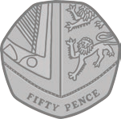

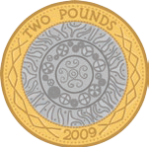



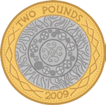

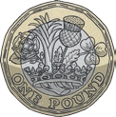



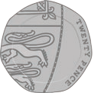

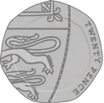

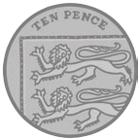

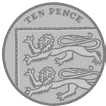

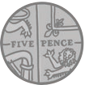

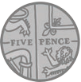

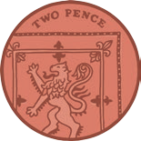



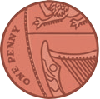

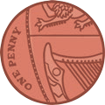

**Draw coins to show one way of making the following amounts of money.**

**Example: 17p**

**10p**

**5p**

**2p**

**10p**

1. 34p- There is various different ways to get 34p.

**2p**

e.g.

**2p**

**20p**

1. £1.22p- There is various different ways to get £1.22p.

2p

20p

£1

e.g.

1. 65p- There is various different ways to get 65p.

10p

5p

50p

**5. An apple costs 42p. How much change would you get from 50p?**



p

42p

8p

**6. How much more is the ball than the boat?**

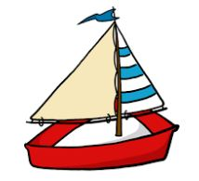



65p

34p

31p

**7. Here is a calendar showing the month of January**

[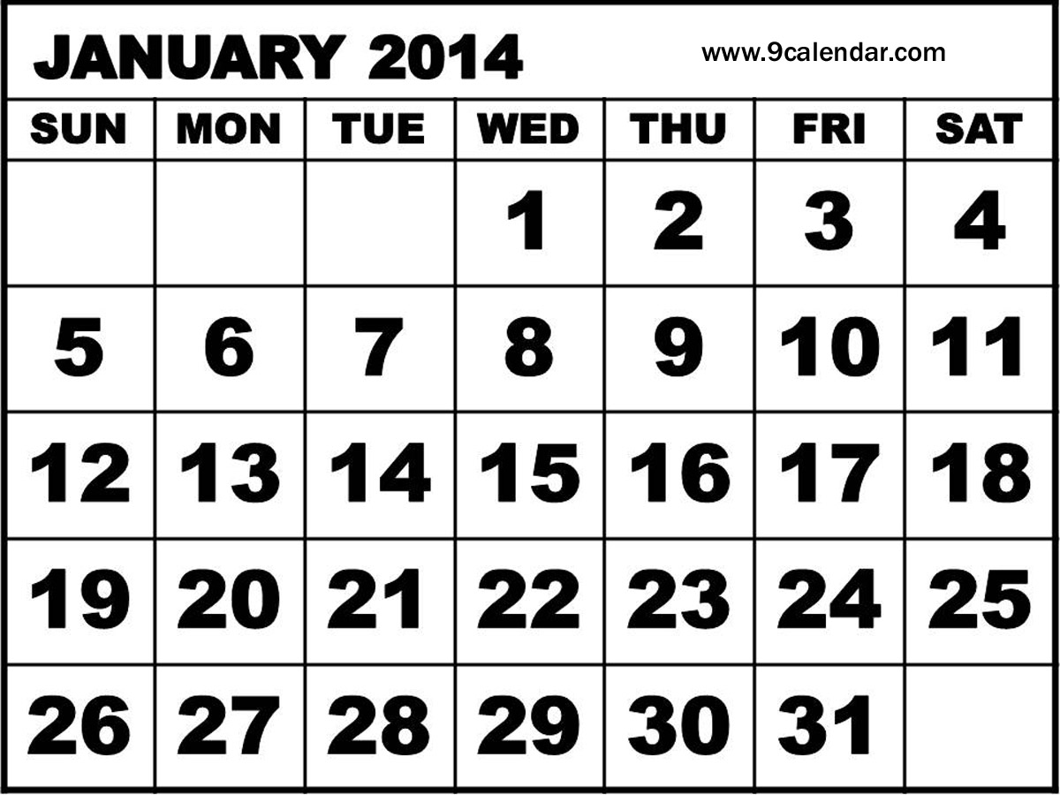](http://www.9calendar.com/wp-content/uploads/2012/11/January-2014-Calendar-with-Holidays.jpg)

1. Fill in the missing dates

5

1. How many Thursdays in January?

Friday

1. What day is the 24st of January?

31

1. How many days in January?

**8) A shop sells 8 t-shirts in 1 day.**

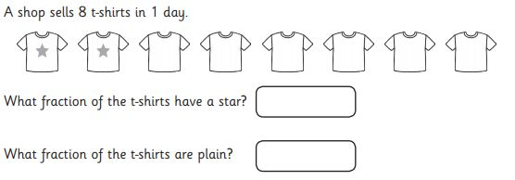

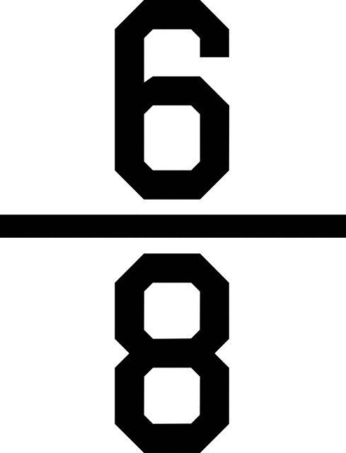

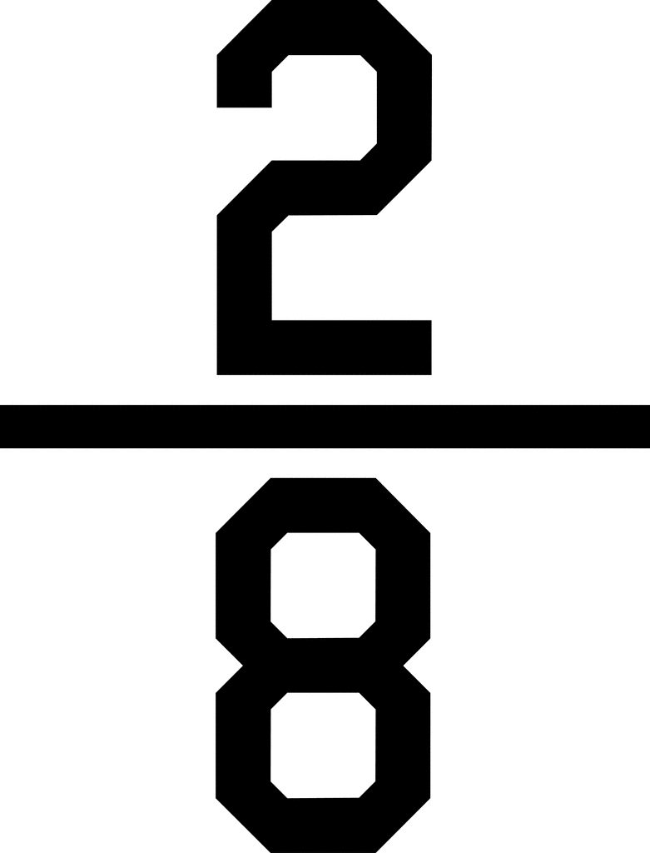

**9. A man has 6 pets. What fraction of the pets are dogs?**

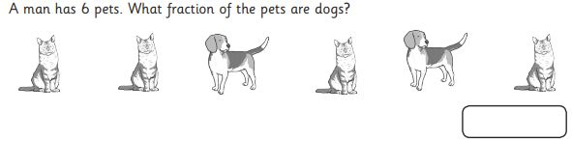



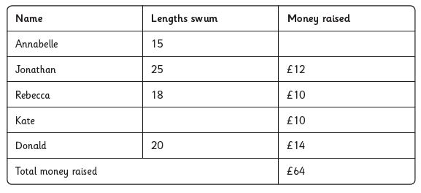**10. Some children did a sponsored swim to raise money for new books for their school.**

Jonathan

1. Who swam the most lengths?

Rebecca and Kate

1. Which two children raised the same amount of money?

23

1. Kate swam 8 lengths more than Annabelle. How many

lengths did she swim?

1. How many more lengths did Jonathon swim than Rebecca?

7

1. Annabelle raised £6 more than Jonathon. How much money did she raise?

£18

**11. The Hundred Square**

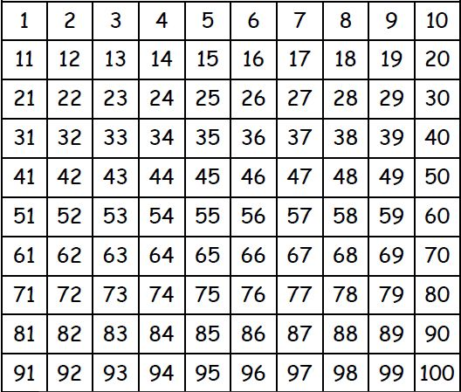

Colour all the odd numbers red and the odd numbers blue.

Odd numbers – ending in 1, 3, 5, 7, 9

Even numbers- ending in 0, 2, 4, 6, 8

Write down an odd number more than 75

Any number under 75 ending in

1, 3, 5, 7, 9

Any number under 30 ending in

0, 2, 4, 6, 8

Write down an even number less than 30.

69

What number is 8 more than 61?

28

What number is 7 less than 35?

**12. What time is it?**

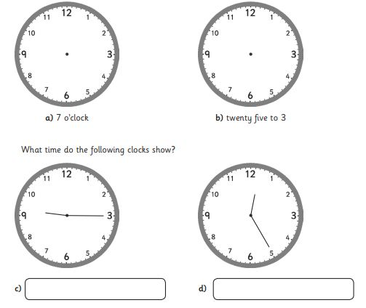

12:25

9 : 15

**13. Write a multiplication or division sentence around the following pictures**

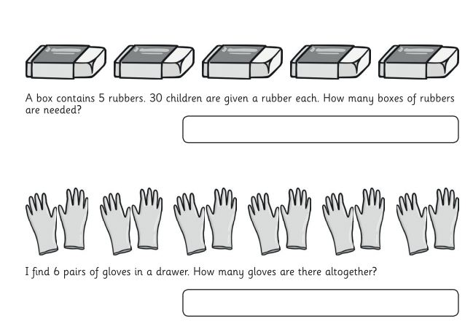

12

30 ÷ 5 = 6 OR 5 x 6 = 30

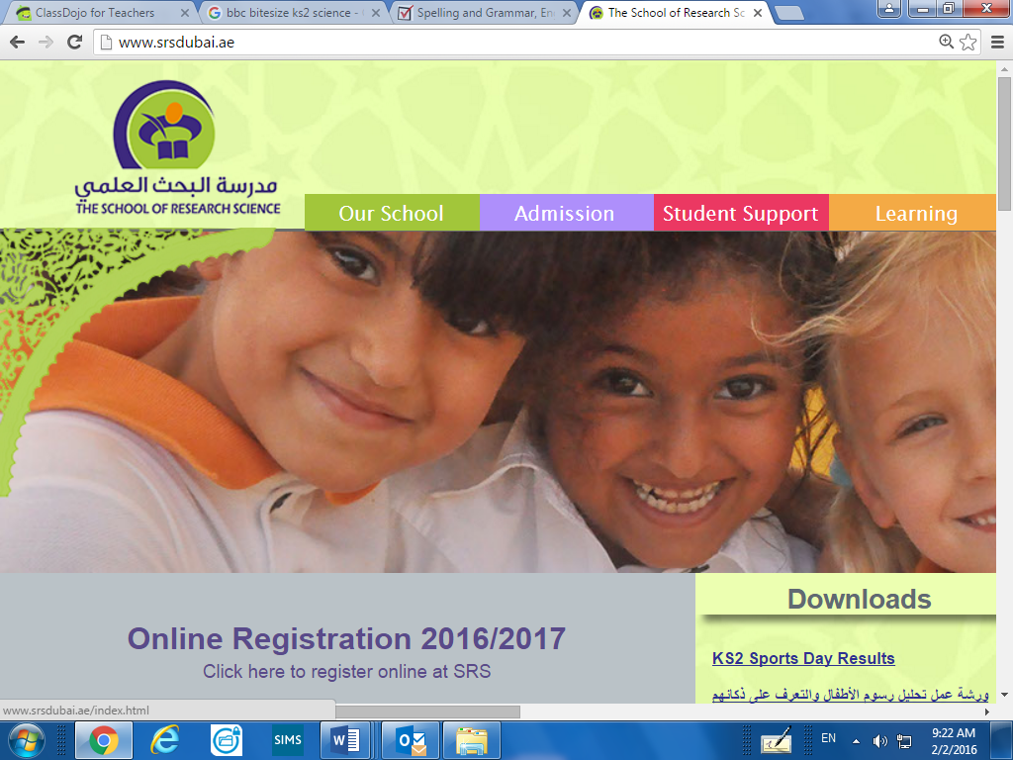

**Website Links**

Visit Year 1 and Year 2 YouTube channels to access videos to recap and revise

**Year 2**

<https://www.youtube.com/channel/UC3vV9h2z-e9wWzrh2-VuD9Q>

**Year 1**

<https://www.youtube.com/channel/UC0EHHYnUEiVw23qxcD-5kEQ>

**Maths Websites**

Shape

<https://www.topmarks.co.uk/maths-games/5-7-years/shapes>

Ordering Numbers

<https://www.topmarks.co.uk/ordering-and-sequencing/caterpillar-ordering>

Place Value

<http://www.ictgames.com/sharkNumbers/mobile/index.html>

All Maths Topics

<http://www.ictgames.com/resources.html>

<https://uk.ixl.com/math/year-2>